Environmental Monitoring Lesson

- Policy
  - Each element in the environmental monitoring program is addressed to minimize the potential for product recontamination. Each of these elements have a detailed, documented plan to address them. A lapse in any one element increases substantially the risk of product recontamination.
  - Prevent ingress or spread of Pathogens in the processing facility.
  - Enhance the stringency of hygiene practices and controls in the primary control area.
  - Apply hygienic design principles to building and equipment design.
  - Prevent or minimize growth of pathogen, spoilage organism, and indicator organism within the facility.
  - Establish a raw materials/ingredients control program.
  - Validate control measures to inactivate Pathogens.
  - Validate Cleaning and Sanitation Program
  - Establish procedures for verification of Pathogen, Spoilage and Indicator Microorganisms controls and corrective actions.

INTENTIONALLY LEFT BLANK

- Procedure
  - Environmental Monitoring Program Requirement
    - Decision Tree for EMP Requirement

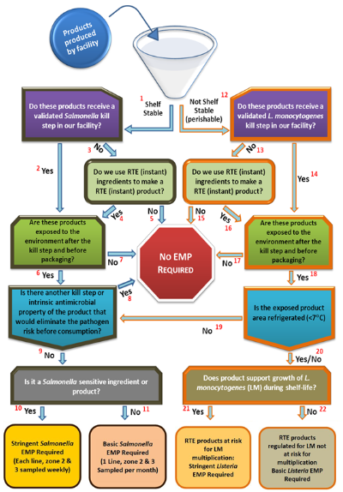

    - Process Steps
Step | Process Steps
1 | Shelf stable products are typically dry or low pH products that would be stored at ambient temperature (flour, extruded pet food, sugar, HFCS, soy meal, cocoa powder, etc.).
2 | Products receive a validated kill step for Salmonella within the facility (oilseed meal, extruded soy, roasted cocoa beans, whey powder, etc.).
3 | Products do not receive a Salmonella kill step within the facility (but may have received a kill step before reaching the receiving facility; cocoa powder, dried milk, soy flour, wheat flour, sugar, lecithin, refined veg oil, etc.).
4 | RTE ingredients are used to make RTE product within the facility (cold pressed cereal bars, powdered milk shake mix, etc.).
5 | Shelf stable products that do not receive a Salmonella kill step in the facility and are not intended to be consumed without a further kill step after leaving the facility (not RTE; wheat flour, whole grains, corn flour, crude veg oil, etc.).
6 | Shelf-stable products are exposed to the environment after the kill step in a way that could reasonably contaminate product if Salmonella were in zones 2 or 3 (extruded pet food, oilseed meal, etc.).
7 | A shelf-stable product receives a kill step and is not exposed to the environment in a way that it could reasonably be expected to be contaminated if Salmonella is in zones 2 or 3 (refined oil going into bulk containers or small containers with minimal environmental exposure).
8 | Shelf-stable products that will receive a further reliable kill step after is leaves the facility or has intrinsic properties that would kill Salmonella even if contaminated (high fructose corn syrup, corn syrup, mayonnaise, crude veg oil, soy flour going to cook-only applications, etc.).
9 | A shelf-stable or perishable product that is considered RTE with no further kill steps and was exposed to the non-refrigerated environment after the facility kill step (RTE extruded soy products, cold-gelling corn starch going into an RTE application, cooked IQF egg packaged in a non-refrigerated area, etc.).
10 | Shelf-stable product exposed after the kill step or perishable product exposed to a non-refrigerated area after the kill step that is a sensitive product for Salmonella and is RTE (chocolate, peanut butter, extruded soy products, etc.).
11 | Same as 10, but not a Salmonella-sensitive ingredient (RTE corn starch, frozen IQF RTE egg products).
12 | Perishable products require refrigerated or frozen storage (RTE turkey, pasteurized eggs, refrigerated sauces, raw ground beef, etc.).
13 | Products do not receive a L.monocytogenes kill step within our facility (but they may have received a kill step before reaching our facility; IQF cooked diced beef, pasteurized liquid egg, pasteurized milk, raw meat, and poultry, etc.).
14 | Products receive a validated kill step for L.monocytogenes within our facility (cooked meats, pasteurized liquid egg, etc.).
15 | Perishable products that do not receive a L.monocytogenes kill step in our facility and are not intended to be consumed without a further kill step after leaving our facility (raw meat and poultry).
16 | We bring in perishable RTE ingredients to produce a perishable RTE product (cooked roast beef brought into the facility and diced, packaged, and sold as a RTE product; cheese is brought into the facility, sliced, and added to gift trays to be sold as RTE).
17 | Perishable products receive a validated L.monocytogenes kill step in the final package or are not exposed to the environment in a way that would reasonably cause product to be contaminated if there was L.monocytogenes in zones 2 or 3 (cook-in-bag RTE meat or poultry products, hot filled sauces, pasteurized liquid egg, etc.).
18 | Perishable products that are exposed to the environment after the kill step and before packaging (sliced RTE meat or poultry product).
19 | Perishable product that is exposed to the environment in a non-refrigerated area (cooked IQF egg products packaged in an ambient temperature pack-off room). Note that with this type of product, both a Salmonella and a Listeria EMP will need to be considered.
20 | Perishable product exposed after the kill step, packed in a refrigerated area (sliced or diced meat and poultry products), or non-refrigerated area.
21 | A perishable product, exposed after the kill step and before packaging and is at risk for L.monocytogenes multiplication (sliced natural turkey with no listeriostatic formulation or post-package kill step).
22 | Same as 21, but product is frozen or formulated to prevent L.monocytogenes growth (RTE meat and poultry products with validated listeriostatic formulations).
(Environmental Monitoring Decision Tree, https://www.foodqualityandsafety.com/)
  - Environmental Monitoring for Pathogens
    - A defined monitoring of the environment of a food manufacturing facility for pathogenic microorganisms. The goal of a EMP is to find and eliminate pathogen contamination in the processing environment They are typically used to (1) verify an overall food safety system (or specific components of a food safety system) and to (2) provide early indication of potential food safety hazards.
  - Environmental Monitoring for Indicator Organism
    - An environmental monitoring of the food manufacturing facility for determining the general microbial condition of food or environment. The presence of indicator organisms does not provide any information on the potential presence or absence of a specific pathogen, nor does it provide an assessment on potential public health risk, but it will determine the hygienic status of the processing equipment and environment, Validate and or verify cleaning sanitation and assess post-processing contamination
  - Environmental Monitoring Spoilage Organism
    - An environmental monitoring of the food manufacturing facility for determining the verification activity of sanitation which will contribute to microbial quality which increase the risk of spoilage incident.
    - Seek and Destroy Process
    - Product Type and Target Microorganism
  - EMP Team
    - EMP team assemble to understand the EMP process flow and emphasize identifying potential points of product recontamination. Use EMP Team Meeting Log Record when EMP meetings are conducted.
  - Zoning and Division on Environmental Monitoring
    - Zoning
      - Zone 1 - Areas direct product/ food contact surfaces where the product is exposed to the plant equipment and environment prior to sealing in the primary packaging. Zone 1 surfaces identified: slicers, peelers, fillers, hoppers, screens, conveyor belts, air blowers, employee hands, knives, racks, worktables.
      - Zone 2—Non-product contact areas in the plant that are closely adjacent to product contact surfaces. Zone 2 surfaces identified: processing equipment exterior and framework, refrigeration units, equipment control panels, switches.
      - Zone 3—Nonproduct contact surfaces that are in open post-lethality product-processing areas, but not closely adjacent to Zone 1 surfaces. Zone 3 surfaces have the possibility of leading to product cross-contamination. Zone 3 surfaces identified: forklifts, hand trucks, carts, wheels, air return covers, hoses, walls, floors, drains.
      - Zone 4—Areas remote from post-lethality product-processing areas. Zone 4 areas, if not maintained in good hygienic condition, can lead to cross-contamination of Zones 1, 2 and 3. Zone 3 surfaces identified: locker rooms, cafeterias, entry/access ways, loading bays, finished product storage areas, maintenance areas.
    - Division
      - Hygienic Zoning-Division of a food manufacturing facility into different areas to avoid food contamination risks. Areas are designated based on risk and can include non-production areas (e.g., offices), basic GMP areas (e.g., raw material storage), and where processed RTE product is exposed to the environment prior to packaging. Hygienic zones should not be confused with environmental monitoring sampling zones, which are used to designate target areas for environmental sampling (i.e., Zones 1-4). Also restrict movement of Hazards from low-risk areas of the factory to medium-risk areas and then to high-risk areas over or near exposed product.
        - Uncontrolled Area- Areas where there are no products (e.g., Offices, Employee parking area)
        - Low Risk Area- Areas where there is product, but none is exposed to the environment (e.g., raw material and finished product storage Area)
        - Medium Risk Area- Areas where product is exposed.
        - High Risk Area- Areas where the product is sensitive to pathogenic growth and goes to sensitive consumers.
        - High Care Zones- Areas over or near exposed products where there is a high probability of contamination.
        - Transition Zones-Areas where barriers and routines exist to prevent the movement of contaminants between areas.
  - Sampling Procedure
    - Sampling methodology (refer to EMP-Sampling Procedure)
    - Environmental Monitoring Sampling Guide and Frequency
  - Type of Testing for pathogen environmental monitoring
    - Surface sampling using sponges or swabs (Refer to EMP-Sampling Procedure)
    - Product residue scrapings/ﬁnes/dust samples (Refer to EMP-Sampling Procedure)
    - Water samples
    - Air samples (Refer to Air Quality Monitoring Program)
    - Finished Product samples
  - Microbial Identification
    - Identification Matrix
Microorganism Identification Matrix
Microorganism | Indicator organism | Pathogenic | Spoilage
Yeast and Molds |  |  | yes
Total Plate Count | yes |  | yes
Lactic Acid Bacteria |  |  | yes
Coliforms | yes
E. Coli | yes | yes
Enterobactericaea | yes
Listeria | yes | yes
Salmonella | yes | yes
Cronobacter spp. |  | yes
Staphylococcus Aureus | yes
    - Microbiological Criteria
      - Microbiological Standards for Ready to Eat Foods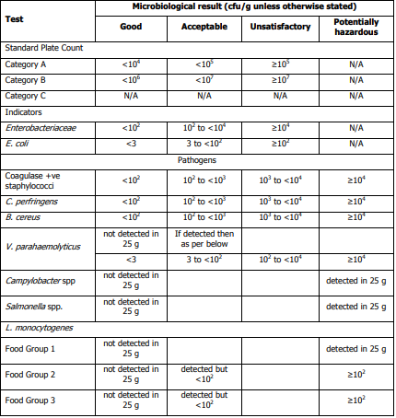
(NSW Food Authority, Microbiological quality guide for ready-to-eat foods A guide to interpreting microbiological results)

      - Standard plate count
        - Category A – applies to ready-to-eat foods in which all components are fully cooked for immediate sale or consumption ( e.g., meat pie)
        - Category B – applies to ready-to-eat foods that are fully cooked with further handling or processing before consumption ( ,e.g., custard filled pastry)
        - Category C – food that contained uncooked fermented ingredients or fresh fruit and vegetables ( e.g., takeaway fruit and yogurt mix)
      - Listeria monocytogenes
        - Food Group 1 – ready-to-eat foods that will support the growth of L. monocytogenes and has been stored prepared for greater than one day ( e.g., packaged sandwiches)
        - Food Group 2 – ready-to-eat food that will not support the growth of L. monocytogenes and has been stored prepared for greater than one day ( e.g., salads and dips with a low pH)
        - Food Group 3 – ready-to-eat food that will be consumed immediately and has not been stored prepared for greater than one day (eg, freshly made sushi)

    - Results Interpretation
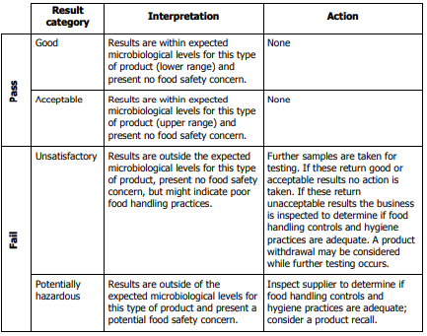
(NSW Food Authority, Microbiological quality guide for ready-to-eat foods A guide to interpreting microbiological results)

    - Recommended microbiological indicator limits for equipment cleaning before and after application of sanitizer and post heat treatment. If the target/limits exceed, reassess SSOPs and GMPs (Table reference: Almond Board of California)
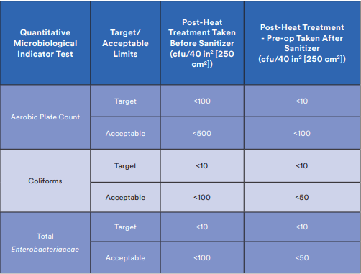
    - Frequency
      - Swabbing frequencies are determined based on “Criticality Indexes” relevant to each specific processing area.
Criticality Index Frequency of Monitoring
- Daily or Each Lot/Batch
- Weekly
- Bi-weekly
- monthly

Zones | Criticality Index
1 | 1
2 | 2
3 | 3
4 | 4
  - Microbial Process Control
    - Microbial Process Control Steps
      - Elimination of the resident organisms of concern is measured by the presence or absence in the verification, indicator site, and investigative sampling programs. Obtaining negative results from these sites over a long term is a key indicator of elimination.
      - Control movement by managing the vectors and pathways. The effectiveness of barriers and hurdles to entry and movement within the exposed product area measures the control of movement.
      - Utilize process control methodology to measure and predict loss of control. , The degree of microbiological process control, is evaluated by plotting collected data (variable and attribute) on control charts and calculation of statistical capability indices.

      - Five stages of microbiological process control within plants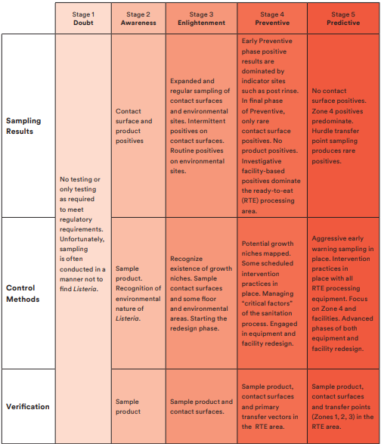
(3M, Environmental Monitoring Handbook for the Food and Beverage Industries 1st edition)
  - Personnel Training
    - Environmental Monitoring Program and applicable forms
    - GMPs
    - Documentation Control
    - SSOPs
    - EMP Sampling Procedure
    - EMP Verification and Corrective Actions

- Responsibility
  - EMP Team
Title/Position | Department
QA Manager | QA/QC
QA Supervisor | QA/QC
Sanitation Manager | Sanitation
Maintenance Manager | Maintenance
Consultant / Subject Matter Expert | Compliance
Production manager | Production
Laboratory Testing/Microbiologist | QA/QC
  - SQF Practitioner

    - Hazard Analysis
    - Hygienic Design Assessment
    - Facility
    - Equipment
      - Utensils Sampling Procedures
  - SQF Practitioner
    - Training and Implementation
      - Hygienic design, construction, and maintenance of the facility.
      - Hygienic operation and maintenance of the processes and equipment.
      - Hygienic Zoning.
      - Application of appropriate (e.g., dry vs. wet) cleaning and disinfection procedures.
      - Training of personnel in food safety and hygienic practices.
    - Microbial Monitoring Objectives
      - Verifying the effectiveness of cleaning and sanitation practices. Refer to SSOP
      - Determining the frequency required for cleaning and sanitation. Refer to SSOP
      - Determining the presence of food-borne pathogens or their indicators in the environment.
      - Discovering environmental sources of spoilage organisms.
      - Determining the frequency required for special maintenance procedures (e.g., changing air filters). Refer to Equipment Maintenance Program
      - Evaluating the hygienic design and fabrication of food-processing equipment and facilities.

- Corrective Action
  - In the event a pathogen is detected during testing, refer to EMP – Verification and Corrective Actions.
  - Train all applicable personnel on this policy
  - Non-compliance will require re-training or dismissal from job duties or termination of employment.

- Review – Quality
  - Control procedures for environmental monitoring shall be reviewed as part of the initial desk audit. Subsequently, these processes will be audited as part of each site audit through observation, review of records, and interviews with operating personnel. Evidence may include
    - There are control procedures in place for food processes;
    - Control procedures are effectively implemented for food processes;
    - High-risk areas are adequately segregated from raw material handling areas;
    - High-risk areas are only serviced by staff dedicated to that function;
    - Post-process areas are not at risk from pedestrian walkways;
    - Protective clothing is provided in high-risk areas;
    - Dedicated tools and equipment are available in high-risk areas;
    - Product transfer between the equipment and between high-risk areas and other areas poses no risk to the product;
    - An effective environmental monitoring program (EMP) is in place;
    - The EMP includes a sampling schedule and responsibility for sampling;
    - Swabbing includes transfer points and joints in equipment;
    - Swabbing records are maintained.
  - EMP Review
    - The environmental monitoring program is reviewed and assessed on an annual basis by the EMP Team - utilize assessment form
    - Data Trending and Analysis shall be used as a tool for interpreting and validating environmental monitoring program effectiveness.
  - Reviews and Approvals
    - Pathogen Testing and Frequency
      - Title: QA Supervisor
      - Dept: QA/QC
    - Pathogen Test Result - Reviews and Determination
      - Title: QA Manager
      - Dept: QA/QC
    - Corrective Action Preventive Actions
      - Title: QA Manager
      - Dept: QA/QC
    - Documentation Validation and Archiving
      - Title: Consultant / Subject Matter Expert
      - Dept: Compliance
    - Record Keeping (Electronic Copy)
      - Title: Consultant / Subject Matter Expert
      - Dept: Compliance

- History
Revision No.: | Revision Date: | Description of Change: | Originator / Author Name: | Title / Department:
0 | 20221115 | Original | Arnel Ryan | PCQI / Compliance

Requirements:
- The trainee (employee/visitor) has read or received a verbal translation of all or part of the policy, procedure, method, and/or SOP for which they are being trained.
- The trainee has observed a demonstration of the task they are to perform or the procedure for which they are being trained as required.
- The trainee has demonstrated the ability to perform the task with acceptable proficiency and minimal supervision.

